**Project Proposal: AgriSphere**

**A) INTRODUCTION**

AgriSphere is a visionary web platform designed to serve as a dynamic hub for agriculture enthusiasts worldwide. Functioning as a comprehensive community, AgriSphere goes beyond conventional forums by integrating cutting-edge features that facilitate seamless knowledge exchange, collaborative discussions, and robust connections among its users. Through a user-friendly interface, AgriSphere endeavors to create an inclusive space where individuals passionate about agriculture can converge, celebrate the diversity within the realm of farming, and contribute to a shared pool of agricultural wisdom.

**B) TARGET AUDIENCE**

AgriSphere has identified a diverse and expansive target audience, encompassing a wide spectrum of individuals engaged or interested in agriculture. Primary beneficiaries include farmers seeking innovative solutions, agriculture students eager to expand their knowledge, researchers investigating novel practices, and anyone with a genuine passion for the agricultural domain. By tailoring its offerings to these varied stakeholders, AgriSphere aims to become the go-to platform for those in search of a virtual community where they can seamlessly share experiences, engage in insightful discussions, and stay abreast of the latest developments in the ever-evolving field of agriculture.

**C) GOALS**

AgriSphere is committed to achieving multifaceted goals that collectively contribute to theenrichment of the agricultural community. The primary objectives are:

Knowledge Sharing: AgriSphere endeavors to provide a robust platform for users to share their agricultural insights, experiences, and best practices. Through features such as blog posts, forums, and multimedia content sharing, users can contribute to a growing repository of knowledge, fostering a culture of collaborative learning.

Community Building: Recognizing the importance of a supportive network, AgriSphere seeks to foster a vibrant community where agriculture enthusiasts can connect, collaborate, and learn from one another. Through specialized interest groups, events, and networking opportunities, AgriSphere aims to create a sense of belonging among its users, transcending geographical boundaries.

Information Access: AgriSphere strives to empower users by enabling them to stay updated on the latest trends, news, and discussions in the field of agriculture. By curating relevant content, providing real-time updates, and facilitating informed discussions, the platform becomes a dynamic resource for individuals keen on staying at the forefront of agricultural advancements.

**D) FLOW CHART OR SITEMAP**

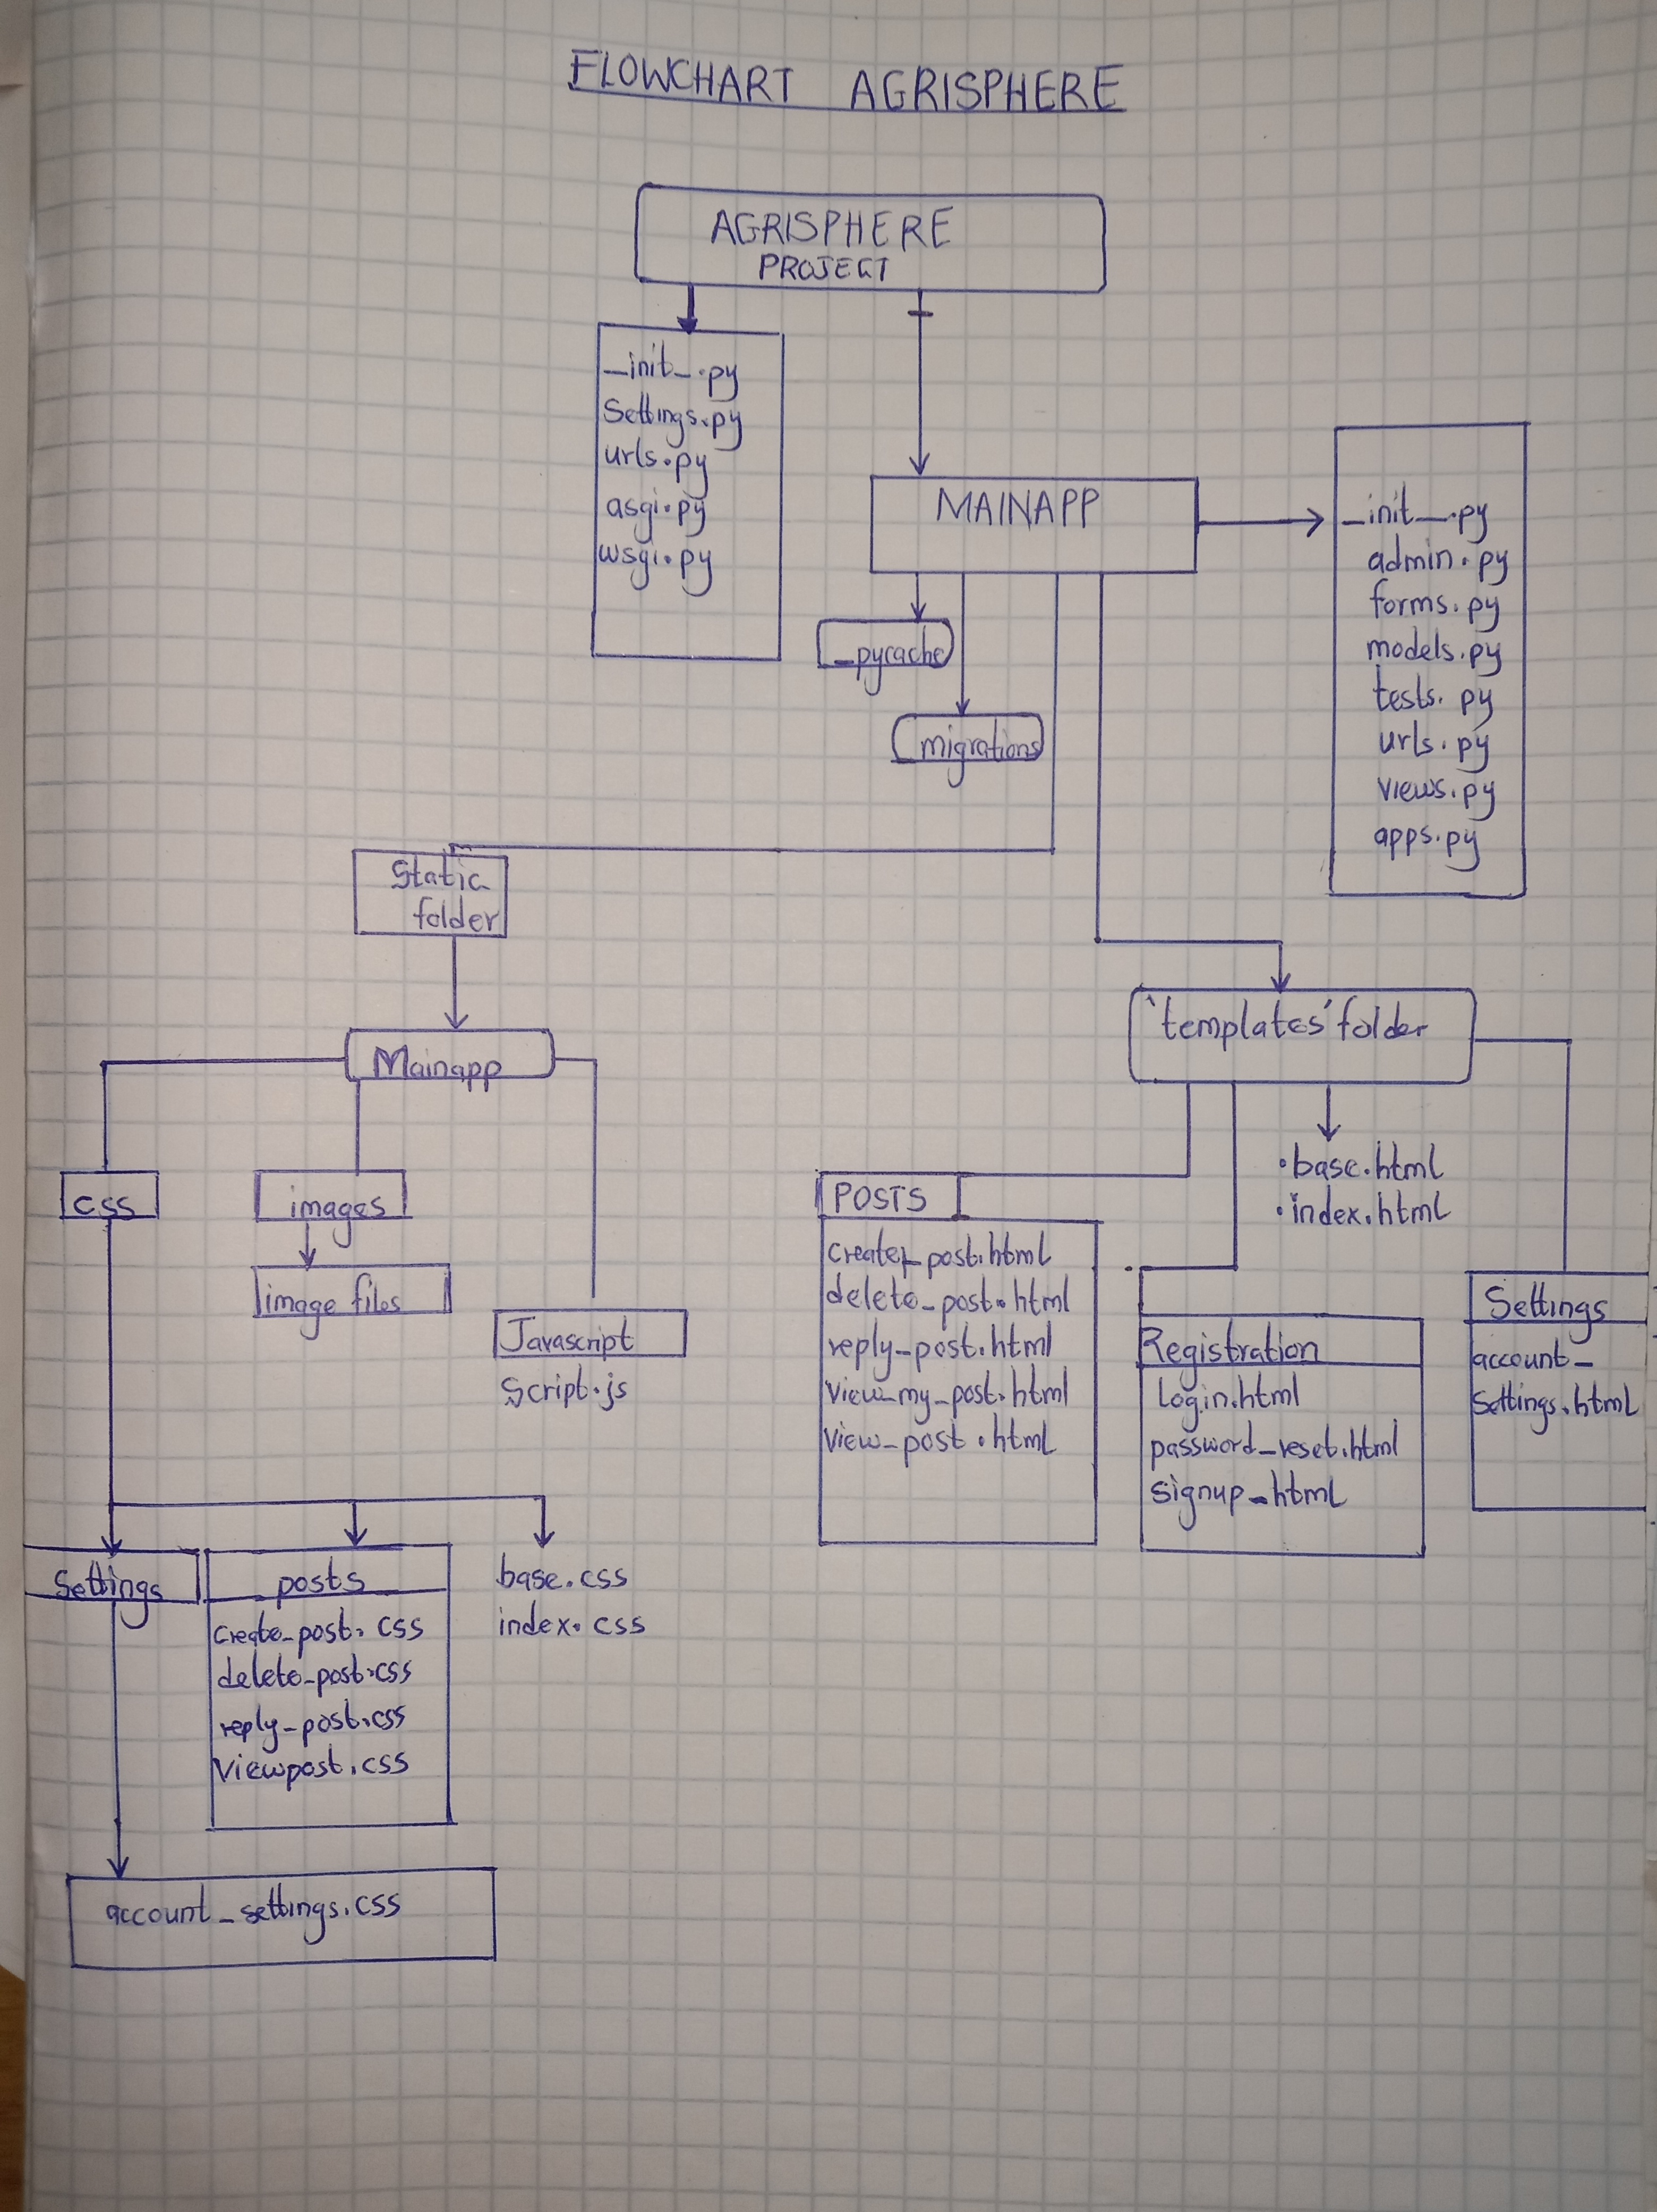

**E) ROUGH SKETCHES**

**HOME PAGE**

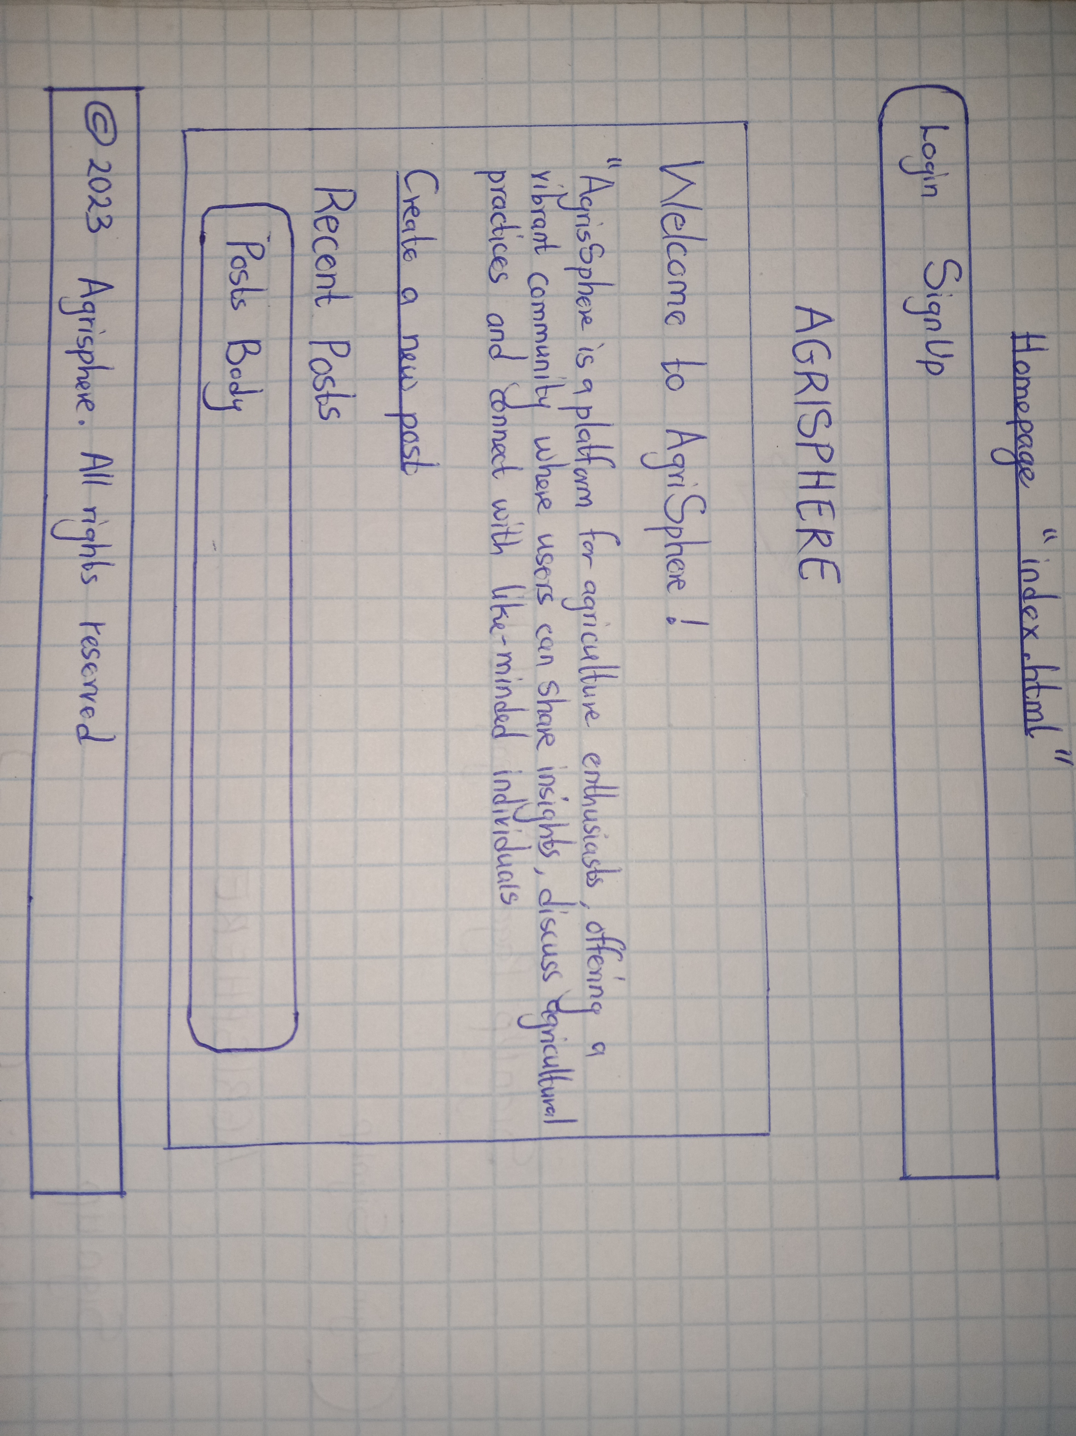

**SIGN UP PAGE**

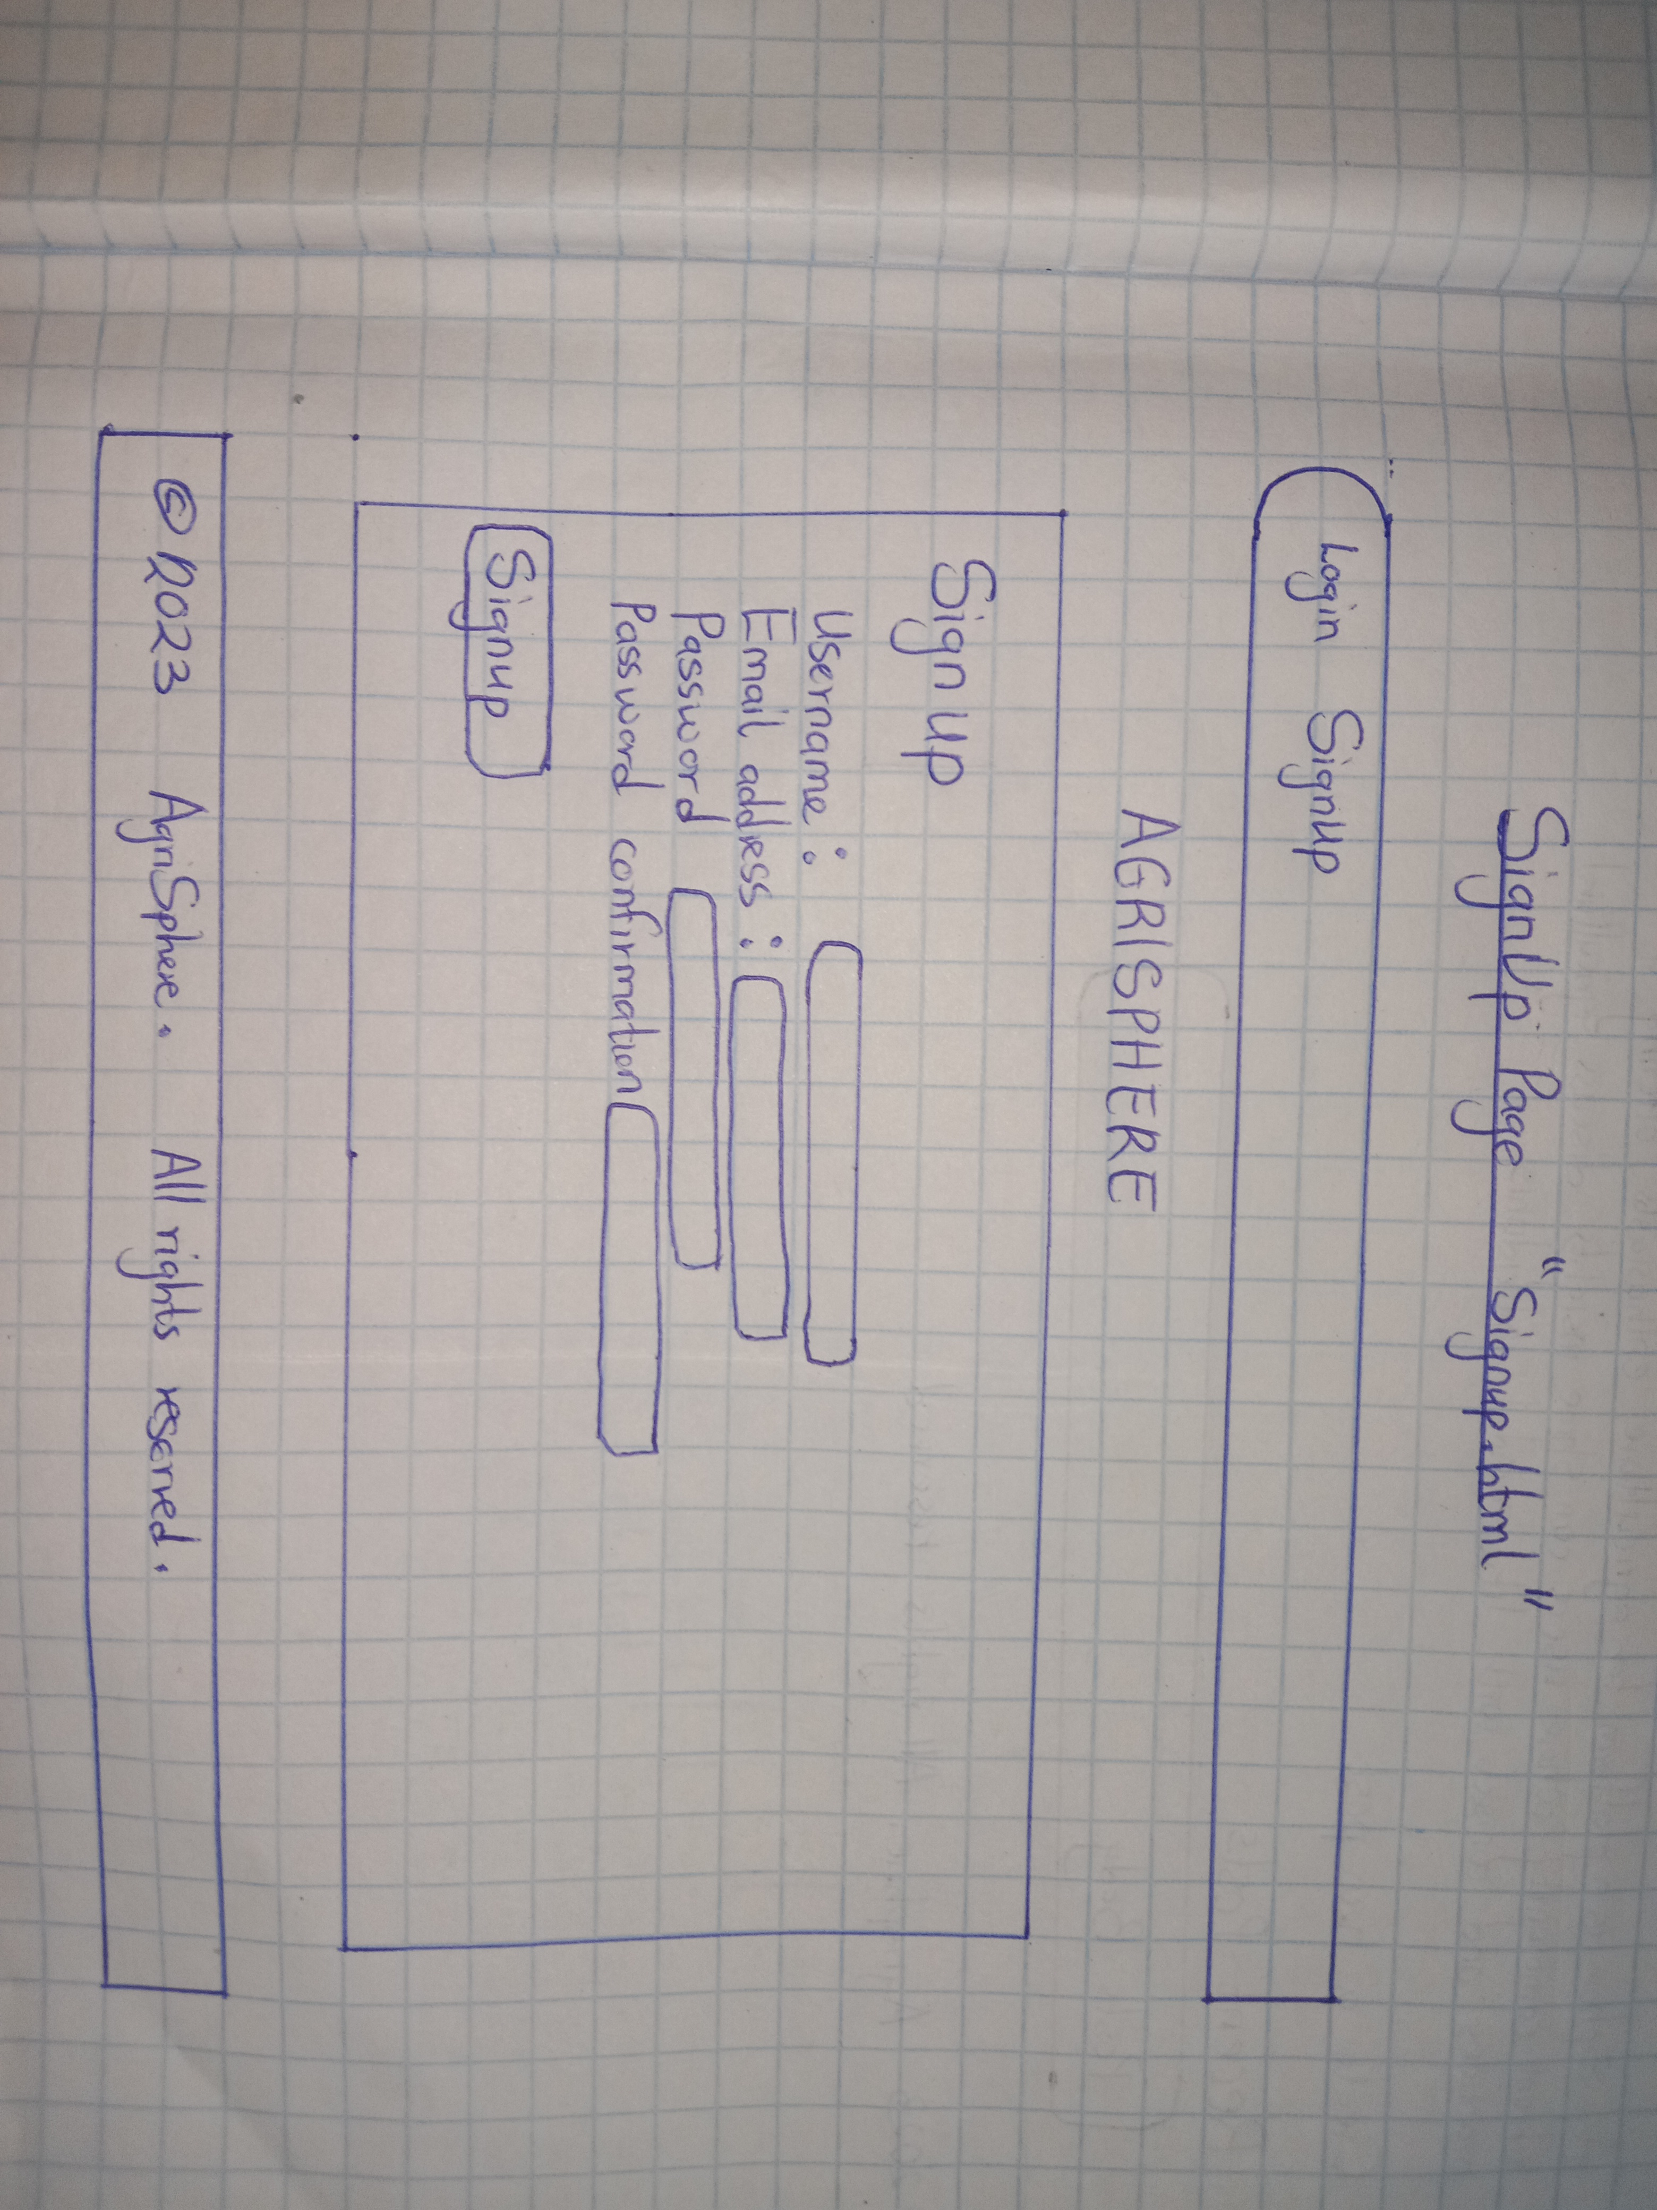

**LOGIN PAGE**

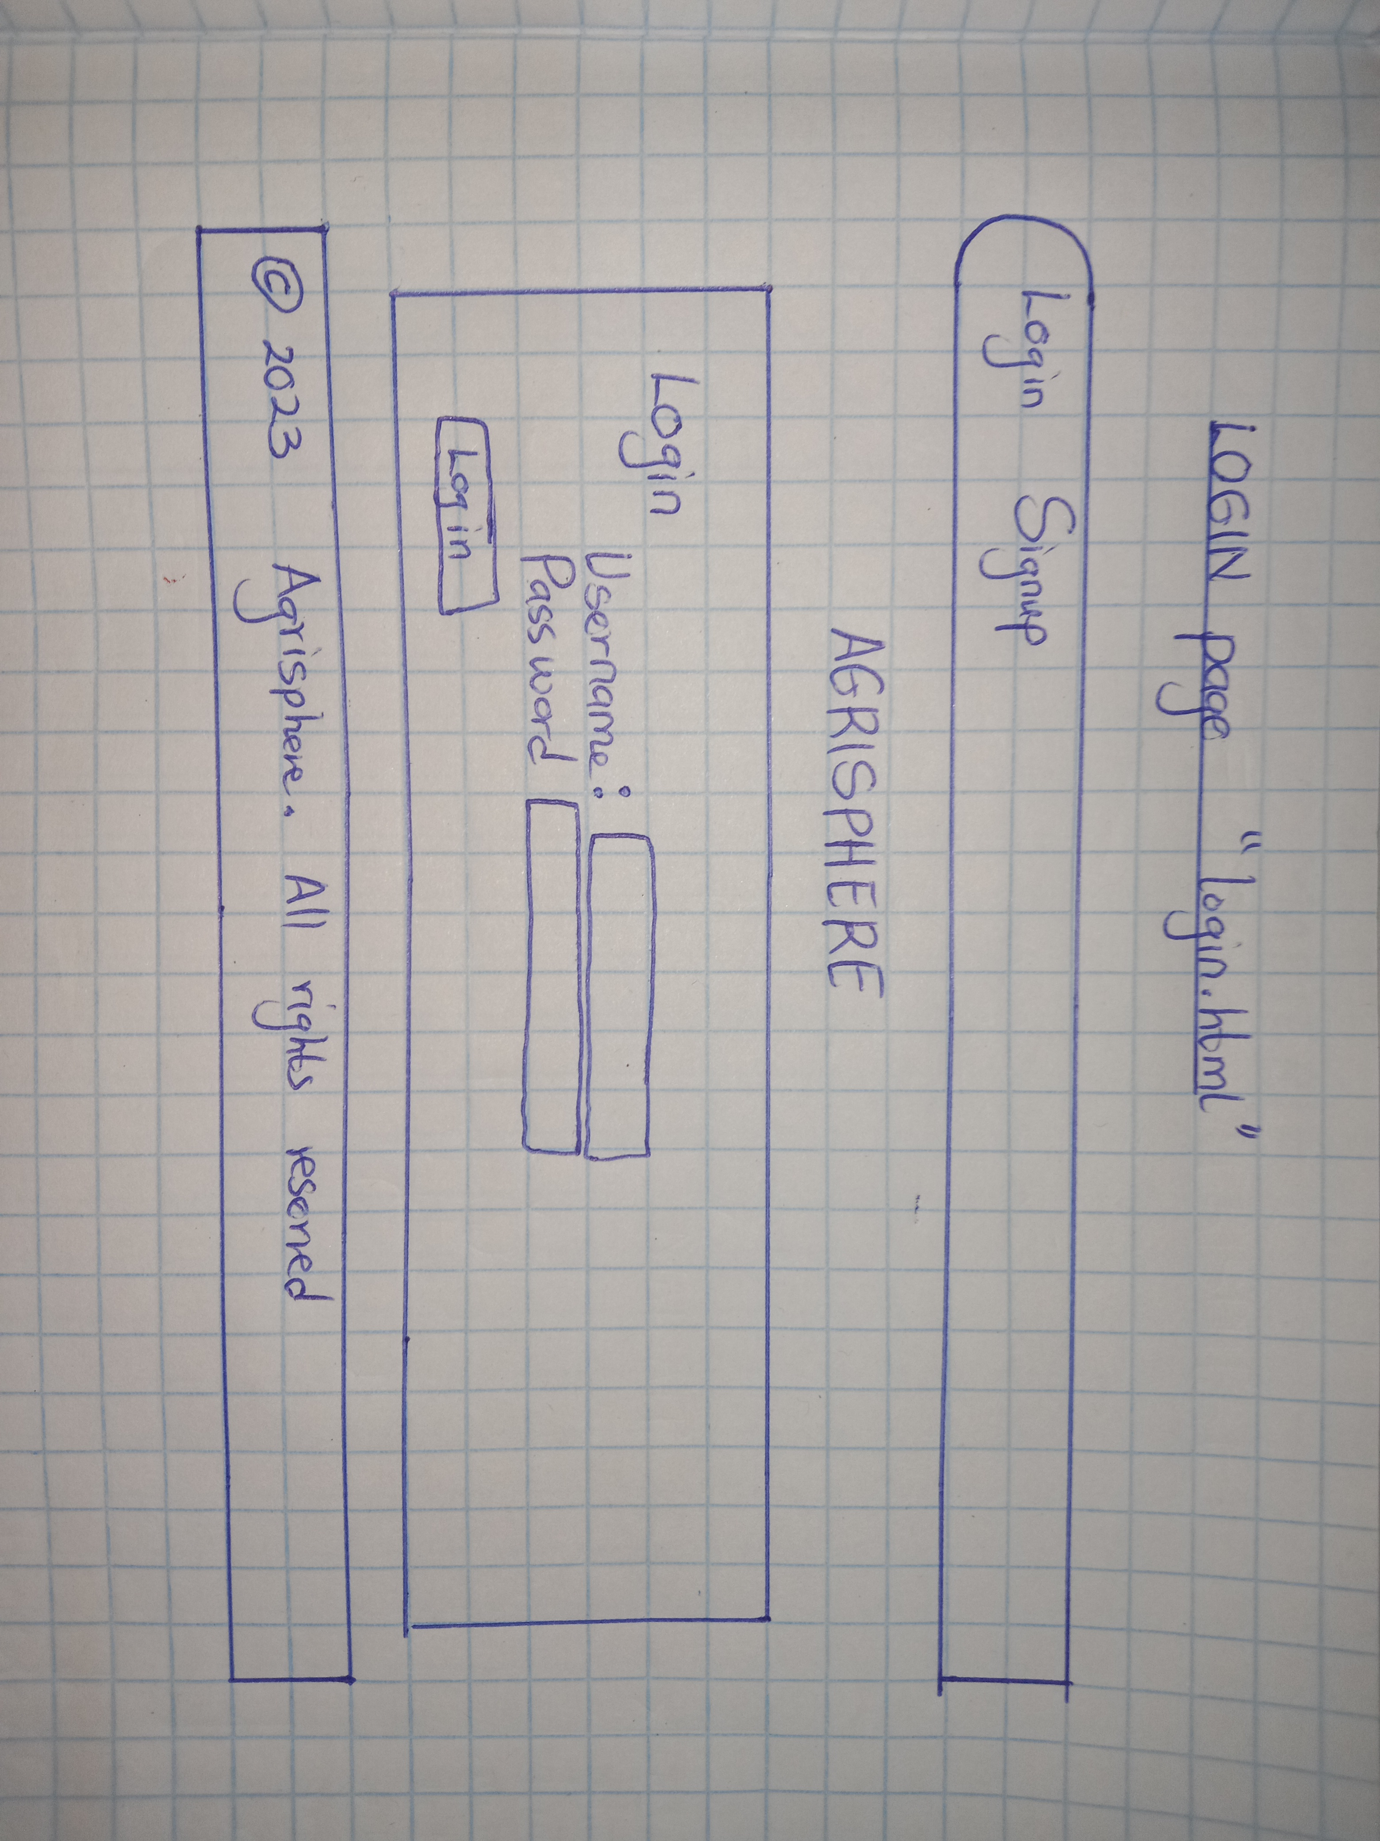

**REQUREIMENTS**

asgiref == 3.7.2

Django == 5.0

django-taggit == 5.0.1

sqlparse == 0.4.4

tzdata == 2023.3

**EXPLANATION**

All the web pages within AgriSphere follow a consistent design framework to ensure a cohesive and visually appealing user experience. This is achieved through the utilization of the base.html file, which serves as the foundational template for the entire website. By extending the base.html file, each specific web page inherits common structural elements, such as the header, footer, and navigation menus, promoting uniformity across the platform.

Additionally, the styling of these web pages is standardized through the implementation of the base.css file. This cascading style sheet acts as a central repository for styling rules, defining the visual presentation of elements across the site. Through the strategic use of the base.css file, AgriSphere maintains a harmonious design language, creating a seamless transition between different pages and enhancing the overall aesthetics of the platform.

This approach not only streamlines the development process but also ensures a consistent and professional appearance throughout AgriSphere. It simplifies maintenance tasks, as updates or changes to the design can be efficiently implemented at the base level, automatically reflecting across all extended web pages. Ultimately, the use of base.html and base.css contributes to a user-friendly and visually cohesive environment, enhancing the overall quality and usability of AgriSphere.

**CONCLUSION**

In conclusion, the seamless integration of various web pages within AgriSphere is facilitated through the extension of the base.html file and the utilization of the base.css file for consistent and appealing styling. This strategic approach ensures a unified and visually cohesive user experience across the platform, enhancing usability and aesthetic appeal.

As AgriSphere takes shape, it becomes evident that its multifaceted approach—encompassing knowledge sharing, community building, and accessible information—is poised to make a significant impact in the realm of agriculture. By fostering a dynamic space where enthusiasts can freely exchange insights, collaborate within a supportive community, and effortlessly access the latest trends, AgriSphere is well-positioned to become a cornerstone for agricultural engagement.

In the broader context, the success of AgriSphere hinges on its ability to cultivate a thriving ecosystem that transcends geographical boundaries, connecting individuals with a shared passion for agriculture. Through the amalgamation of technology and community-driven initiatives, AgriSphere stands as a testament to the potential of digital platforms in fostering collaborative learning and contributing to the collective growth of the agricultural community. As users continue to contribute, connect, and stay informed, AgriSphere is poised to evolve into a dynamic force, driving positive change and innovation within the agriculture sector.